**DAILY ONLINE ACTIVITIES SUMMARY**

|  |  |  |  |  |  |  |  |
| --- | --- | --- | --- | --- | --- | --- | --- |
| **Date:** | **30 May 2020** | | | | **Name:** | **K ISHA HEGDE** | |
| **Sem & Sec** | **4th sem** | | | | **USN:** | **4al18cs031** | |
| **Online Test Summary** | | | | | | | |
| **Subject** | | **Data communication (18cs46)**  **Complex analysis , probability & statistical methods (18mat41)** | | | | | |
| **Max. Marks** | | **30** | | **Score** | | **Dc-27**  **Maths-29** | |
| **Certification Course Summary** | | | | | | | |
| **Course** | **Cloud foundation ; introduction to cybersecurity & quiz on data & computer communication network** | | | | | | |
| **Certificate Provider** | | | **Great learning** | **Duration** | | | **3hrs** |
| **Coding Challenges** | | | | | | | |
| **Problem Statement:I have solved 1 problem statement** | | | | | | | |
| **Status: executed** | | | | | | | |
| **Uploaded the report in Github** | | | | **Yes** | | | |
| **If yes Repository name** | | | | **[http://github.com/iishaii/locked-down_coding](http://github.com/iishaii/locked-down_coding" \o "http://github.com/iishaii/locked-down_coding)** | | | |
| **Uploaded the report in slack** | | | | **Yes** | | | |

Online Test Details: (Attach the snapshot and briefly write the report for the same)

Certification Course Details: (Attach the snapshot and briefly write the report for the same)

Coding Challenges Details: (Attach the snapshot and briefly write the report for the same)

**ONLINE TEST SUMMARY**:

Today **DATA COMMUNICATION (18cs46)** was conducted of first module. Total marks for the test was 30.

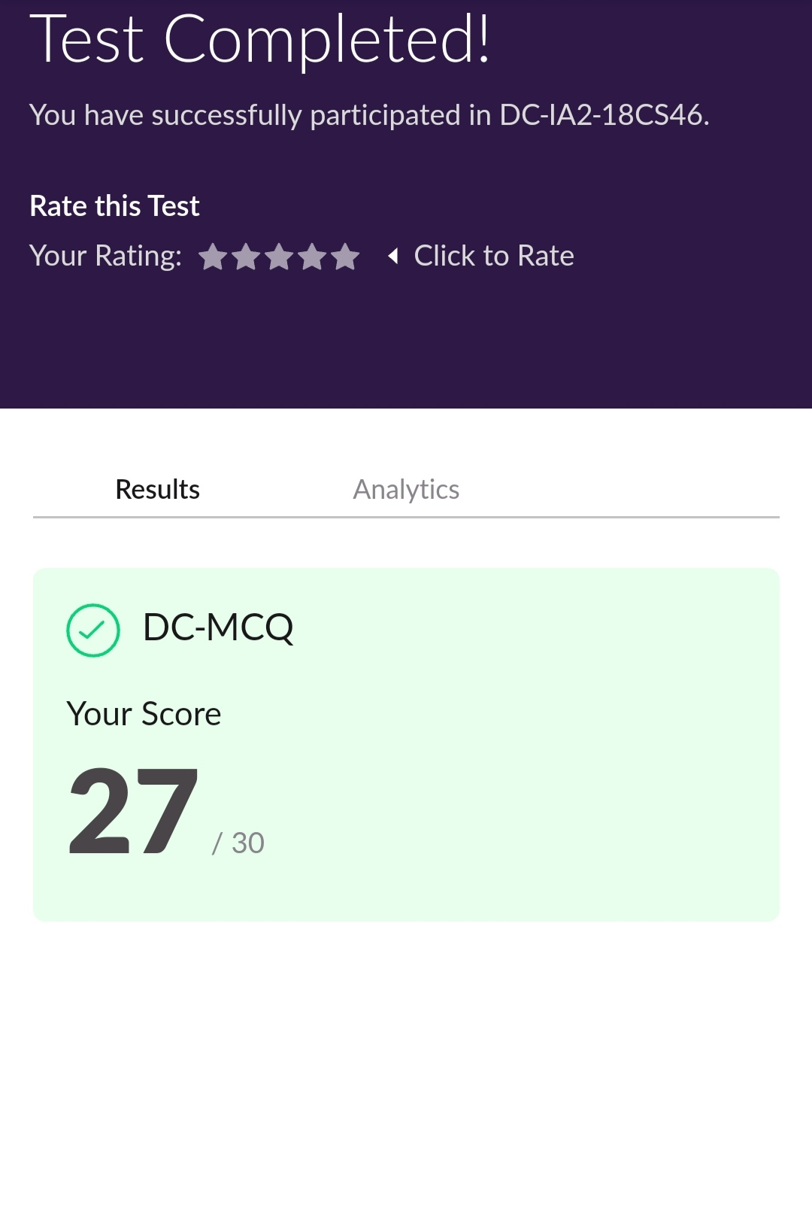

Today 18MAT41 also conducted for 30 marks which is divided into two parts 10 questions of 1 mark and 10 questions of 2 marks at 3:00 Pm.

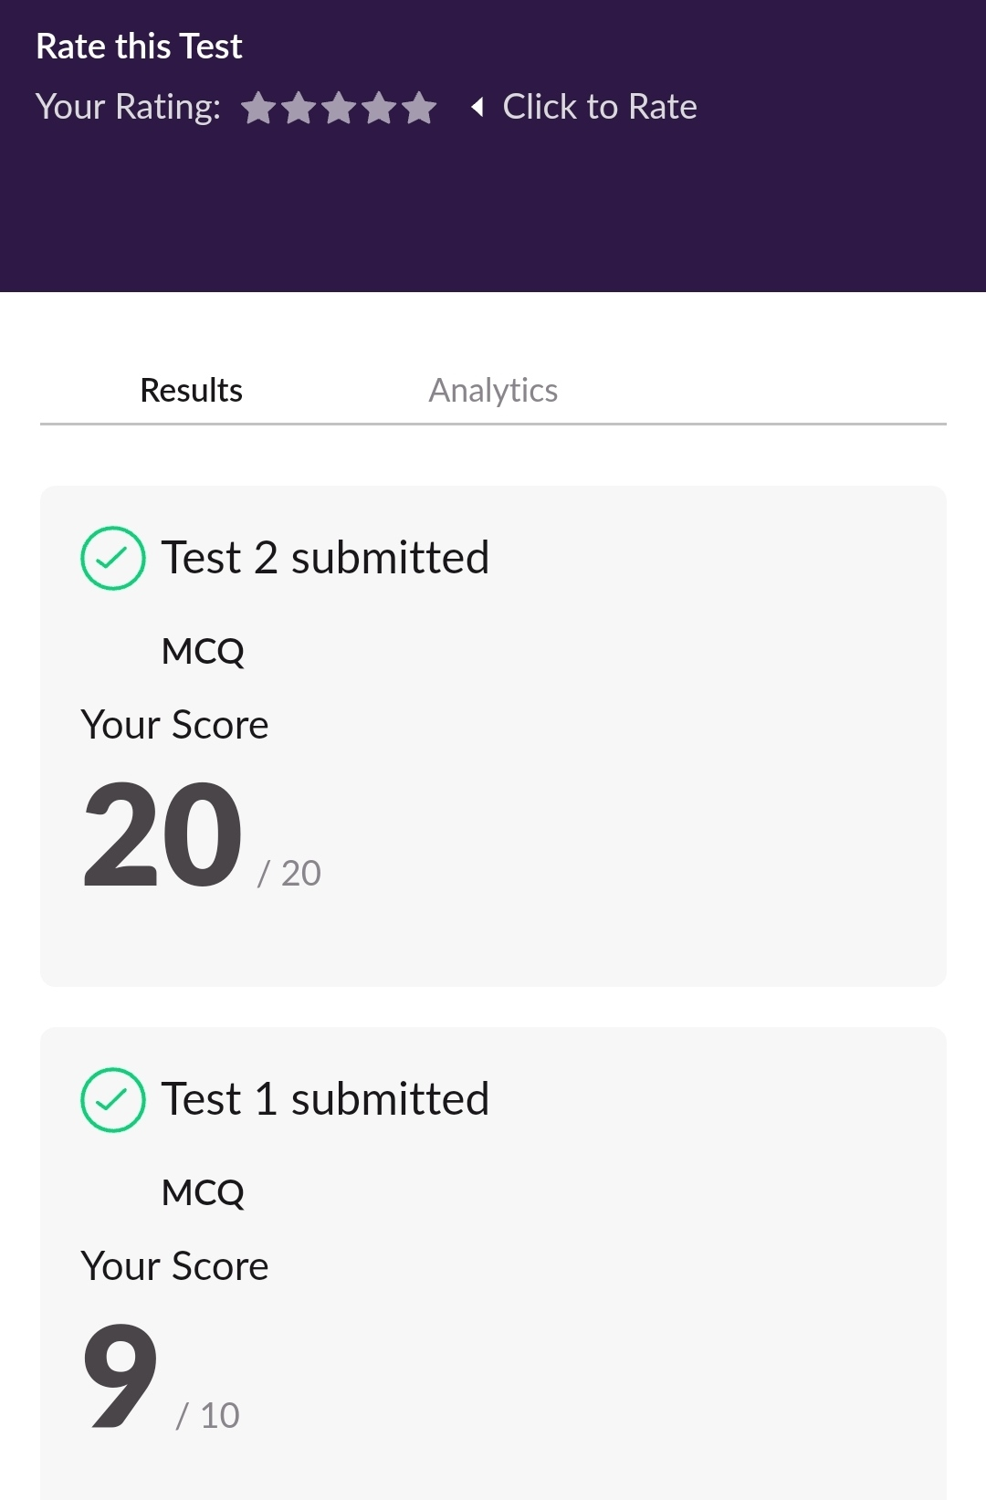

**ONLINE CERTIFICATION COURSE SUMMARY:**

**1. INTRODUCTION TO CYBER SECURITY.**

I continued with cybersecurity and completed the last two modules in cyber security

It took me about an hour for each module. I covered

* Threats and vulnerabilities
* What is cybersecurity

I got a clear veiw of the topics that were thought and discussed.

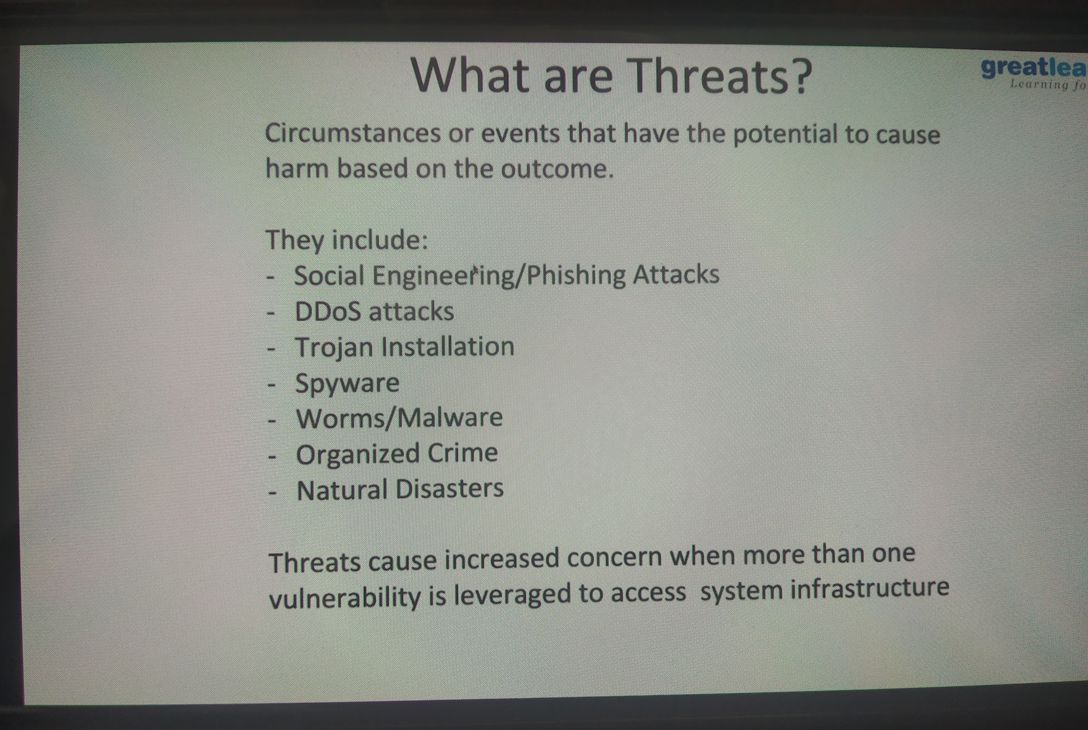

And I successfully completed certication course on CLOUD FOUNDATION

Time allotted for the quiz was half an hour and secured certificate.

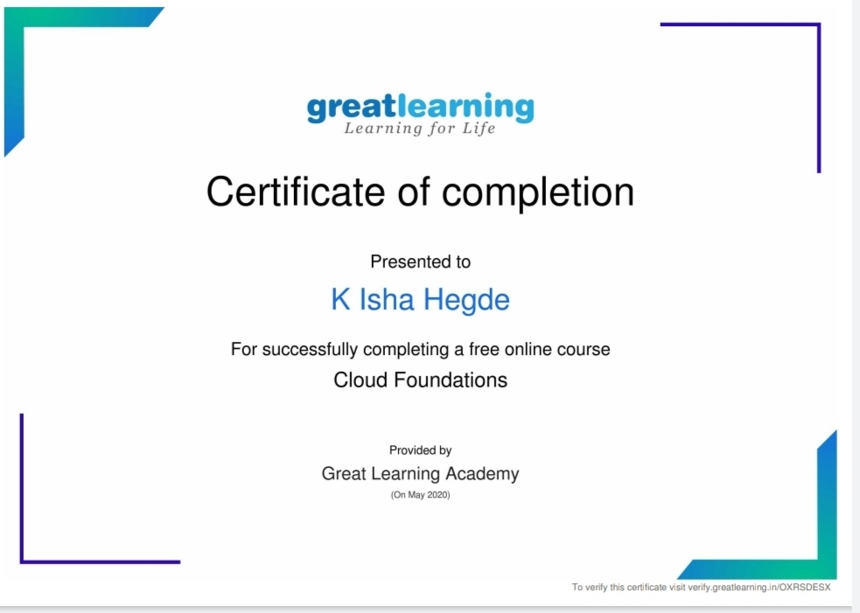

RL jalappa institute of technology conducted quiz on DATA & COMPUTER COMMUNICATION NETWORK. I secured 95% and also certificate.

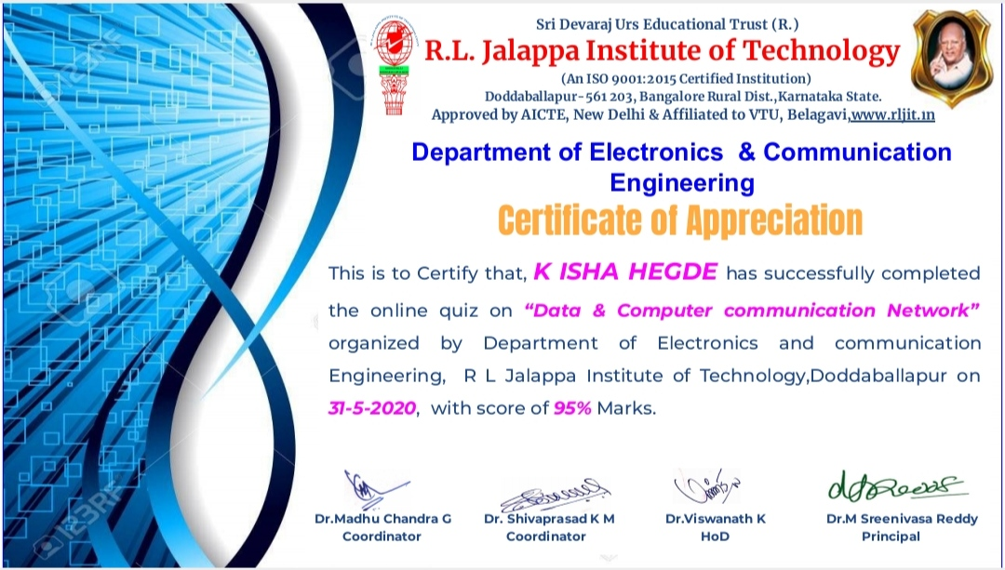

CODING CHALLENGE:

Today I solved one coding challenge.

Write a c program to count uppercase, lowercase,special character and numerical values for given string .

